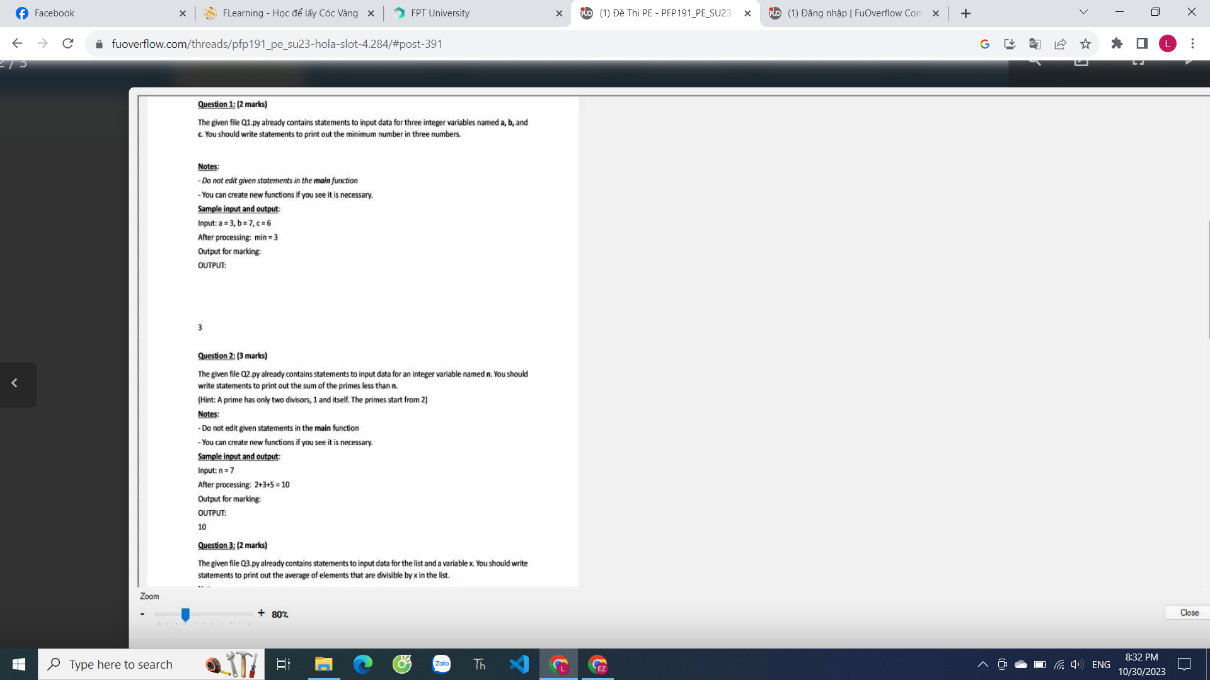

←

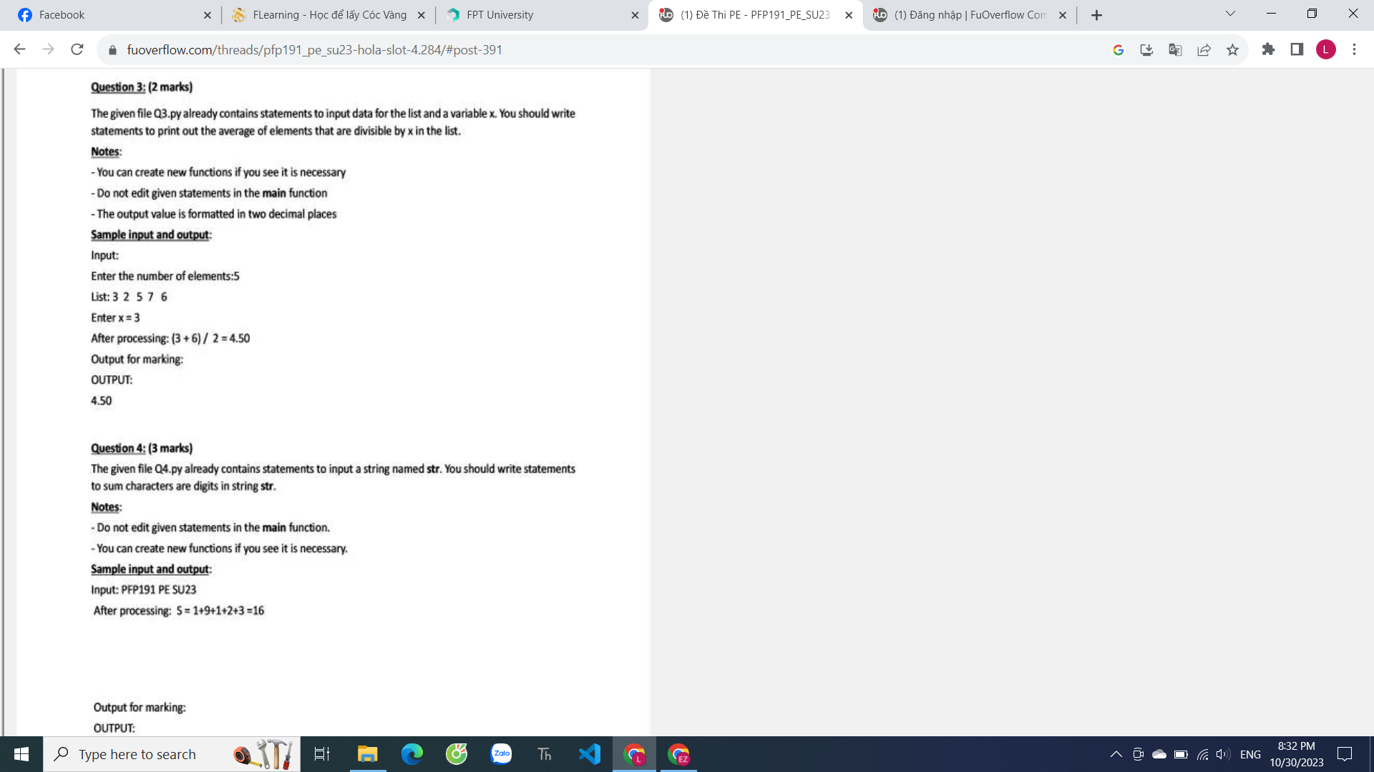

question1

#You can edit this function, if other function is neccessary, you can edit in this function

def Q1(a, b, c):

if a > b:

if b > c:

return c

else:

return b

else:

if a < c:

return a

else:

return c

#---------Do not edit this function---------

def main():

a = int(input("Enter the number 1:"))

b = int(input("Enter the number 2:"))

c = int(input("Enter the number 3:"))

rs = Q1(a, b, c)

print(rs)

if __name__ == "__main__":

main()

question 2

#You can edit this function, if other function is neccessary, you can edit in this function

def check_prime(number):

cnt = 0

for i in range(1, number+1):

if number % i == 0:

cnt += 1

if cnt == 2:

return True

return False

def Q2(n):

total = 0

for number in range(1, n):

if check_prime(number):

total += number

return total

#---------Do not edit this function---------

def main():

n = int(input("Enter the number:"))

rs = Q2(n)

print(rs)

if __name__ == "__main__":

main()

Question 3

#You can edit this function, if other function is neccessary, you can edit in this function

def Q3(lst, x):

new_lst = []

for i in lst:

if i % x == 0:

new_lst.append(i)

return round(sum(new_lst) / len(new_lst), 2)

#---------Do not edit this function---------

def main():

n = int(input("Enter the number of element:"))

lst = []

for i in range(n):

number = int(input("List:"))

lst.append(number)

x = int(input("Enter x = "))

rs = Q3(lst, x)

print(rs)

if __name__ == "__main__":

main()

quention 4

#You can edit this function, if other function is neccessary, you can edit in this function

def Q4(string):

lst = ["0", "1", "2", "3", "4", "5", "6", "7", "8", "9"]

total = 0

for text in string:

if text in lst:

total += int(text)

return total

#---------Do not edit this function---------

def main():

string = input("Input:")

rs = Q4(string)

print("After processing:", rs)

if __name__ == "__main__":

main()